UNIVERSITY OF MINNESOTA

Duluth Campus Department of Studies in Justice, Culture, and Social Change 228 Cina Hall
College of Arts, Humanities, and Social Sciences 1123 University Drive
Duluth, Minnesota 55812-3306
E-mail: troufs@d.umn.edu
ZOOM: https://umn.zoom.us/my/troufs
26 December 2024

Welcome to Anthropology 1080 Global Cultures: How to Access Your Canvas Class

We will be using the Canvas learning management system for this course.

You can find information about the textbook and other resources in your Canvas Syllabus.

During the pre-term period, you may want to familiarize yourself with the Canvas Modules for the weekly course materials.

How to Find and Access Your Canvas Class

Further instructions follow, but if you want, and your browser permits, the URL https://canvas.umn.edu will take you to your Canvas home (your browser may require that you double-click).

Or you can enter from the UMD WebSite on any WebPage . . .

REM: Links on screenshots are not “hot” (active)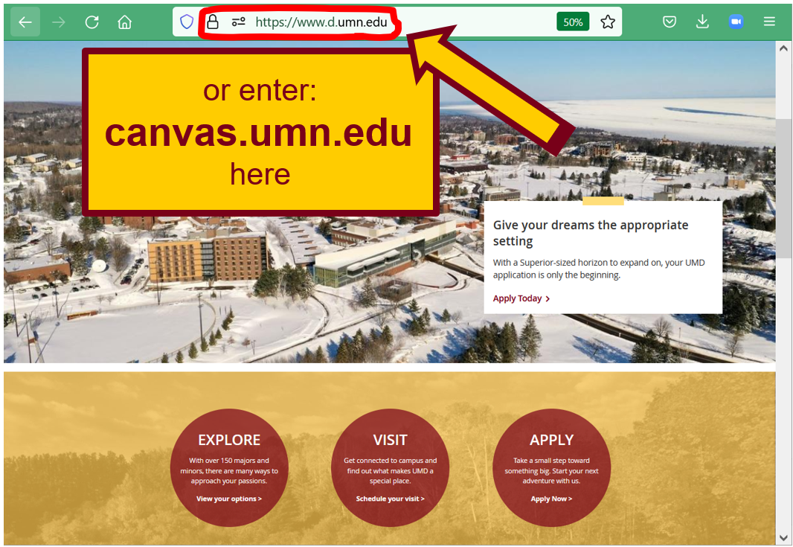

If you are on one of the supporting class WebPages, simply click on the Canvas link . . .

REM: Links on screenshots are not “hot” (active)
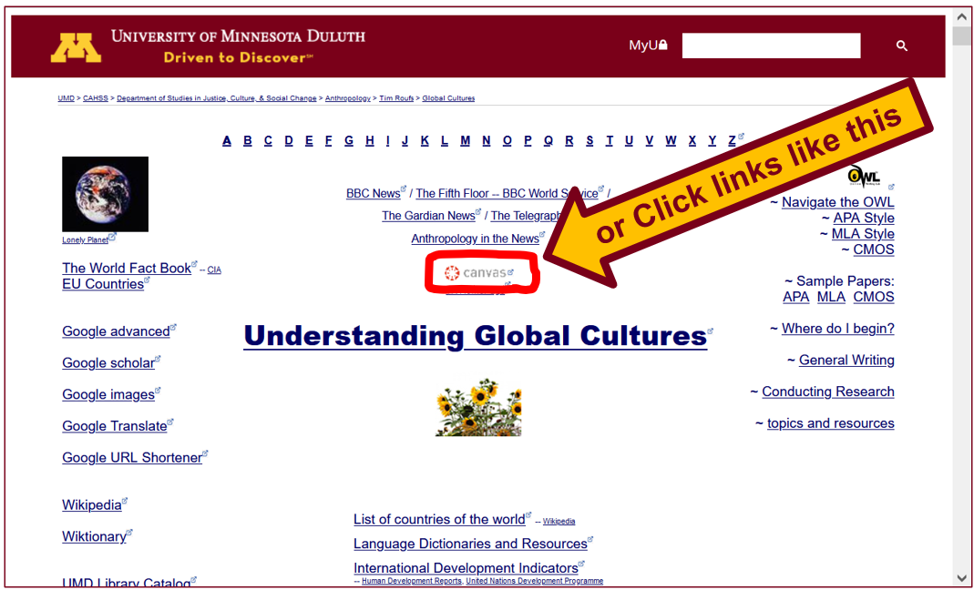

Your log-in page will then present the UM Canvas sign in prompt . . .

REM: Links on screenshots are not “hot” (active)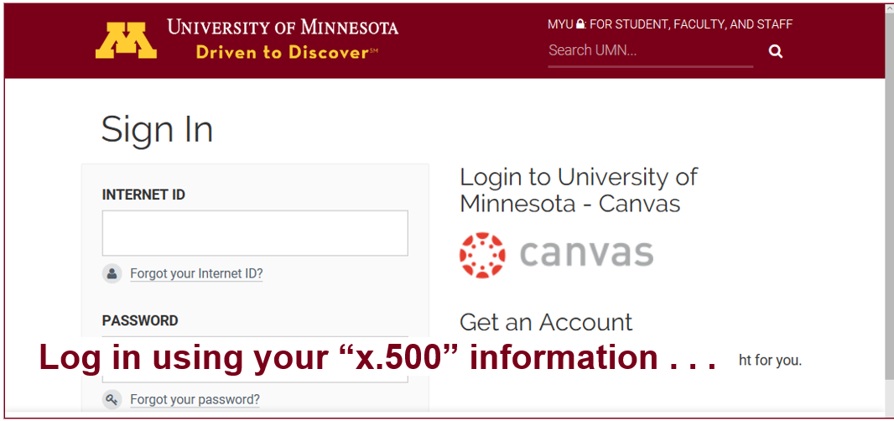

Your sign in will then bring you to the “Duo Push” screen . . .

REM: Links on screenshots are not “hot” (active)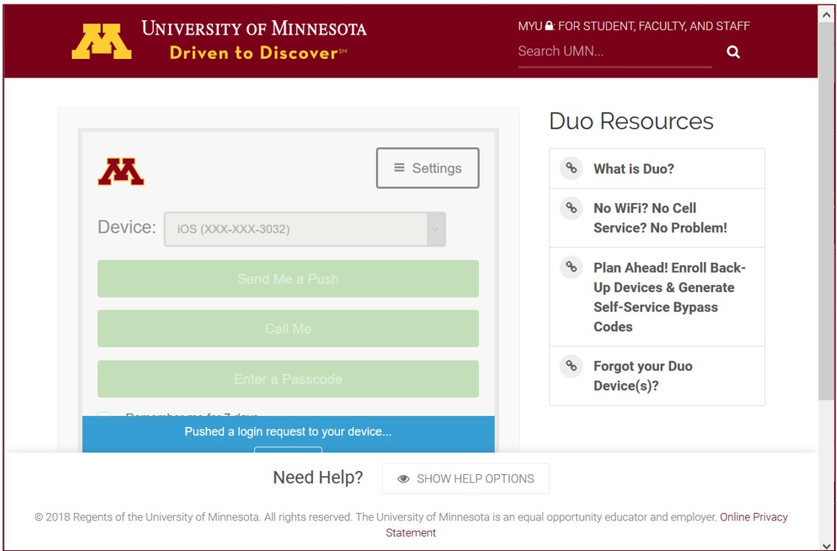

And the “Duo Push” will send a Login Request (generally) to your phone . . .

REM: Links on screenshots are not “hot” (active)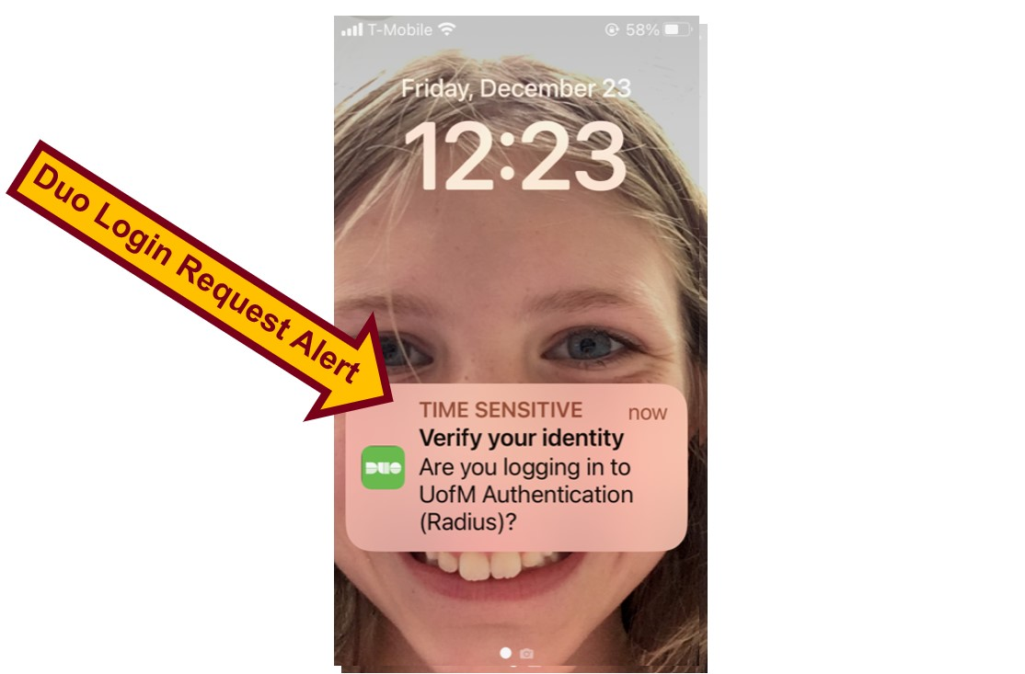

Approve the Login Request and “Bob’s your uncle” . . . (1887 Lord Salisbury?)

REM: Links on screenshots are not “hot” (active)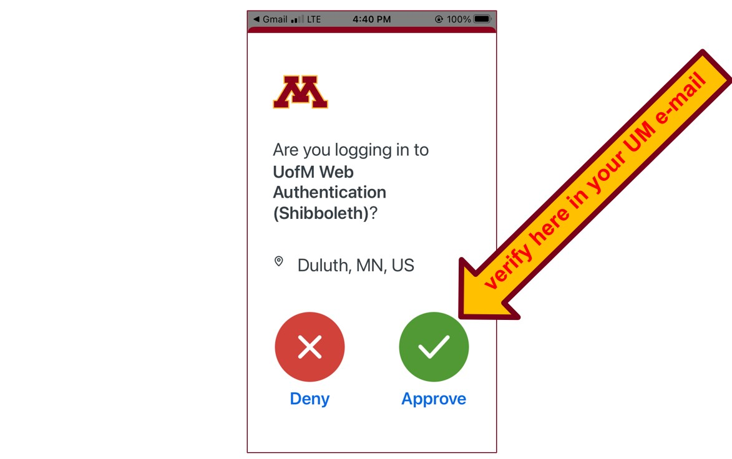

Your Canvas “Dashboard” on your laptop will look something like this . . .

REM: Links on screenshots are not “hot” (active)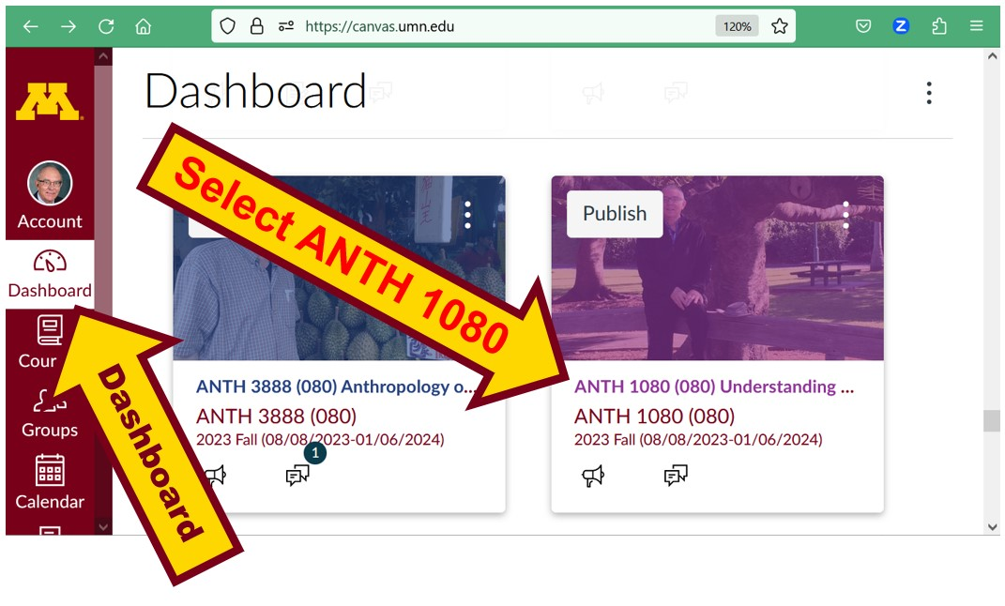
Your Canvas “Dashboard” on your phone will look something like this. . .

REM: Links on screenshots are not “hot” (active)
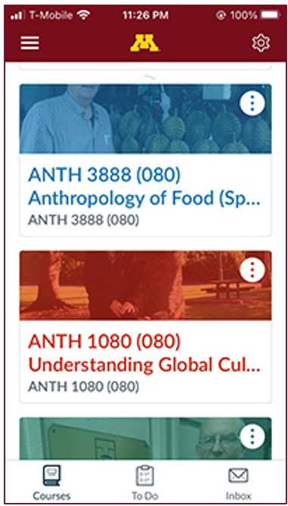

To access the UMD Canvas Course Management System for the 1080 Global Cultures course simply click on the ANTH 1080 (080) Understanding Global Cultures icon on a Dashboard . . . and that will take you to the Canvas Course.

It will take you to your Canvas “Home” screen which on your laptop will look something like this . . .

REM: Links on screenshots are not “hot” (active)


And on your phone your Canvas Home screen looks something like this . . .

REM: Links on screenshots are not “hot” (active)
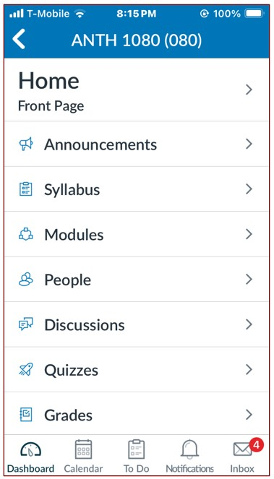

NOTE: Not all Canvas features work on phone apps. . . .
And different phone models work differently . . .

Where to Begin?

Have a look at the Syllabus . . .

REM: Links on screenshots are not “hot” (active)
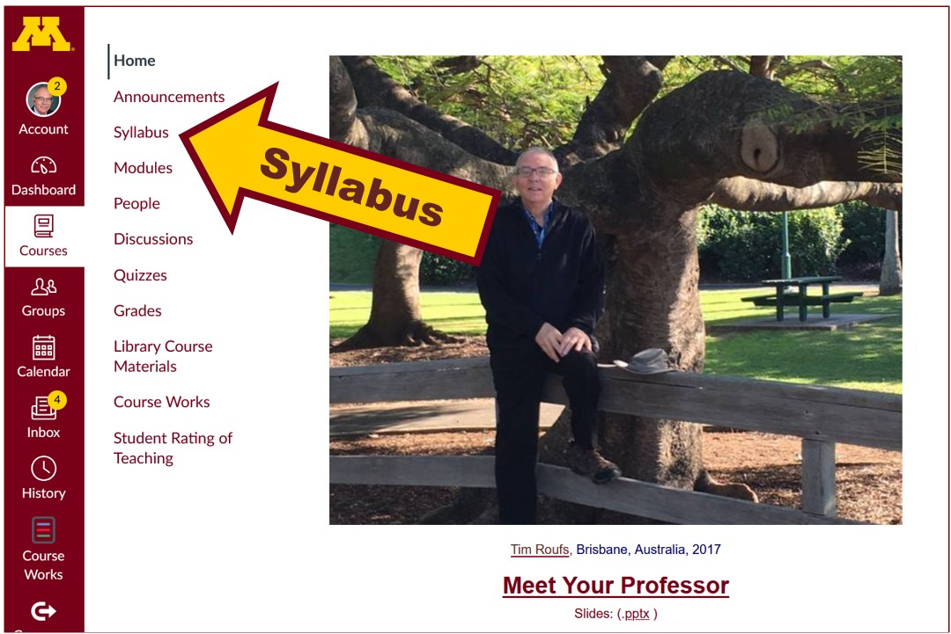

Have a look and give it a try, and if you have any questions, or suggestions, or comments, please let us know at troufs e-mail.

Best Wishes,

Tim Roufs

<http://www.d.umn.edu/~troufs/>
<https://umn.zoom.us/my/troufs>
<other contact information>

P.S. If you are new to Canvas, go to the Getting Started Module, Step 2: Setting Up Your Canvas Account, and Step 3: Review the Student Services and Technology Help Information.

